Project :- Secure Static Website Hosting using Amazon S3 and CloudFront

Designed a secure static website hosting architecture using Amazon S3 and Amazon CloudFront. The solution uses a private S3 bucket with Origin Access Control (OAC) to prevent direct public access, while CloudFront edge locations cache and deliver content globally, reducing latency and improving performance.

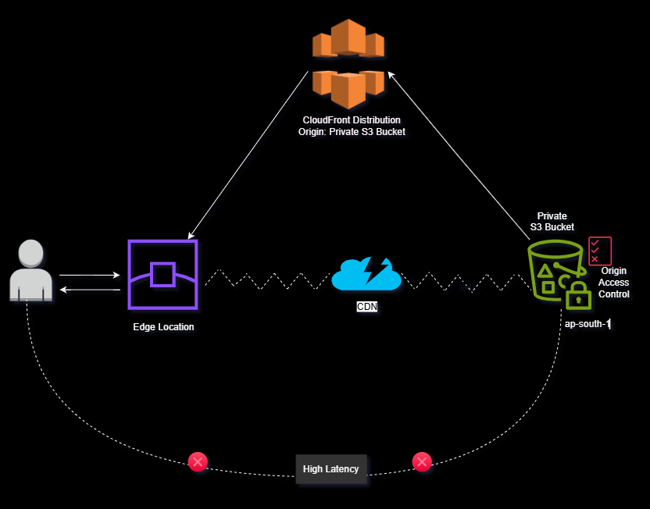

What This Project Demonstrates
This project shows important AWS concepts:

1. CDN: - Using Amazon CloudFront for global content delivery.
2. Security: - Private S3 bucket.
3. OAC: - Secure communication between: CloudFront → S3
4. Caching: - Edge location caching.
5. Cache Invalidation: - Cache Invalidation: Clearing cached objects so users receive updated content.

Step 1 — Create S3 Bucket
Go to
AWS Console → S3 → Create bucket
Settings:
Bucket Name: my-secure-static-site
Region: ap-south-1 (Mumbai)
Important:
Block Public Access → ENABLED
Do NOT enable:
Static website hosting
Create bucket.
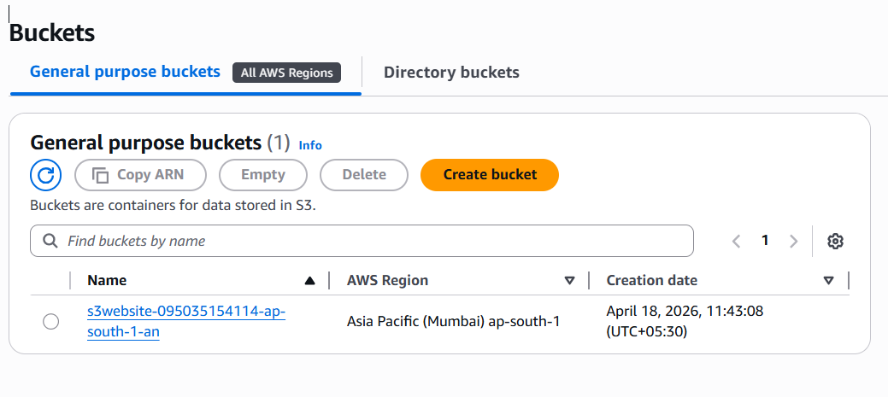
Step 2 — Upload Website Files
Upload:
Upload your files
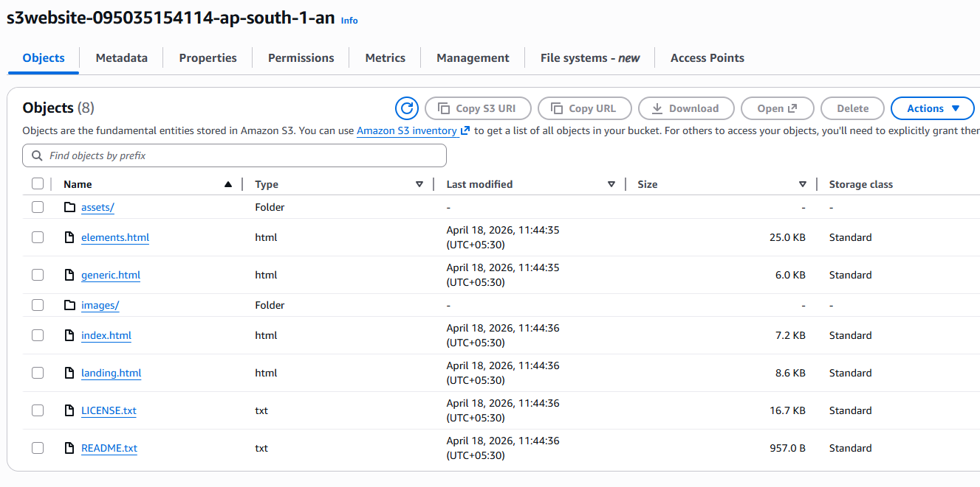

Step 3 — Create CloudFront Distribution
Go to
CloudFront → Create Distribution
Origin settings:
Origin type → S3
Origin domain → select your S3 bucket

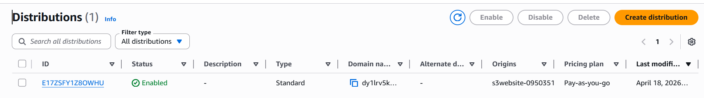

Step 4 — Configure Origin Access
Choose:
Origin Access → Origin Access Control (OAC)
Click
Create new OAC
Settings:
Signing behavior → Sign requests
Origin type → S3
Create OAC.
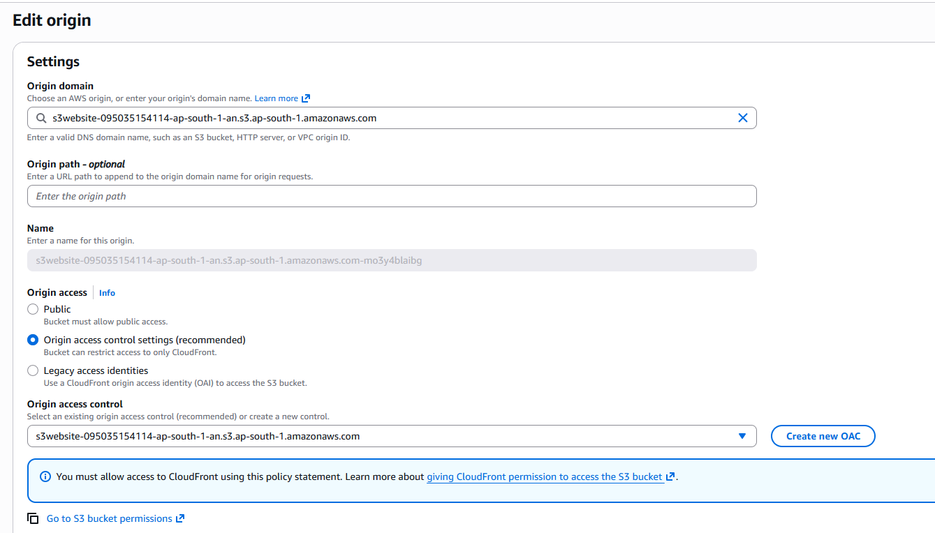
Attach it to the distribution.

Step 5 — Configure Distribution Settings
Recommended settings:
Viewer Protocol Policy → Redirect HTTP to HTTPS
Cache Policy → CachingOptimized
WAF → Disabled (for this project)
Default root object → index.html
Create distribution.

Step 6 — Update S3 Bucket Policy
CloudFront will generate a policy.
Copy it.
Go to:
S3 → Bucket → Permissions → Bucket Policy
Paste the policy.
Only CloudFront can access S3
Users cannot directly access S3
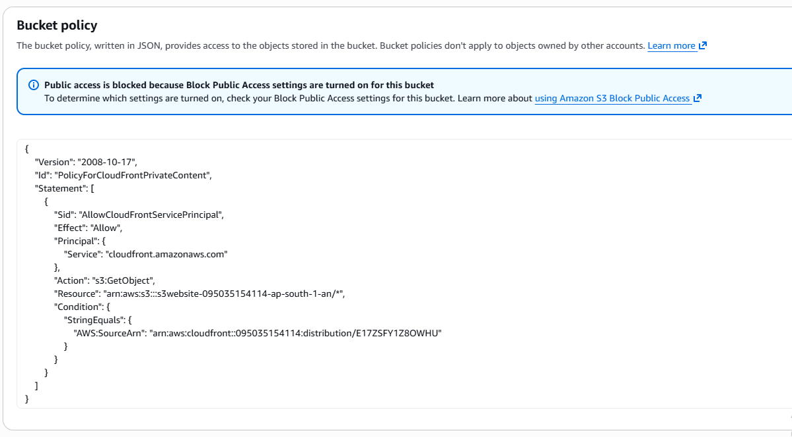

Step 7 — Access the Website
CloudFront will generate a domain :
dy1lrv5knqdhl.cloudfront.net
https://dy1lrv5knqdhl.cloudfront.net

Website loads from Edge Locations.
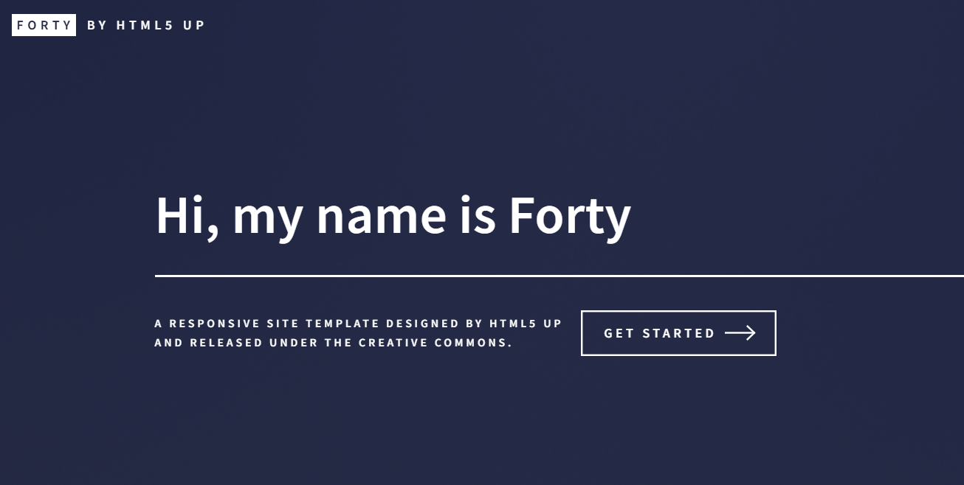

Step 8 — Modify Website Content
Now suppose you change text in:
index.html
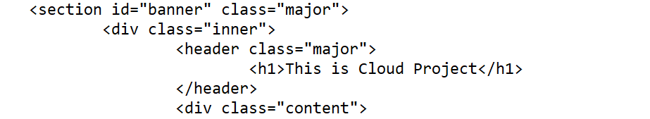
Upload the updated file to S3 bucket.
Step 9— Why Changes Don't Appear Immediately
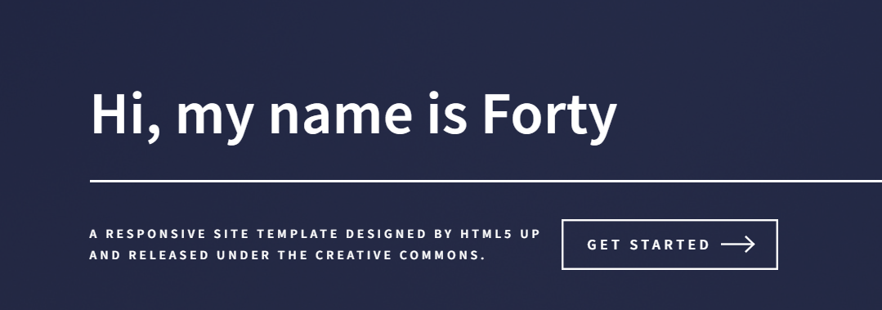

Because CloudFront caches files.
Edge locations already stored the old version.
User → Edge location
Edge location → cached index.html
So users see old content.

Step 10 — Cache Invalidation
To update content:
Go to
CloudFront → Distribution

Click on Invalidations
→ Create invalidation.
Path: /index.html Or invalidate everything: /*
Click: → Create Invalidation
CloudFront clears cached files.
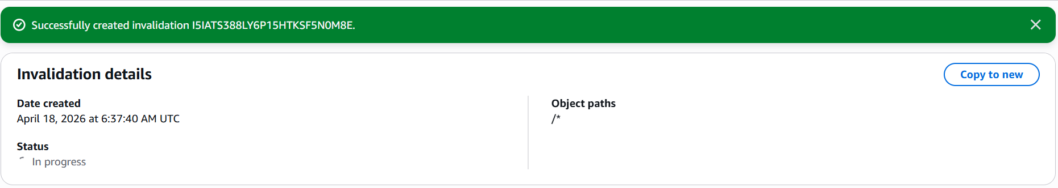

Now users receive updated content.
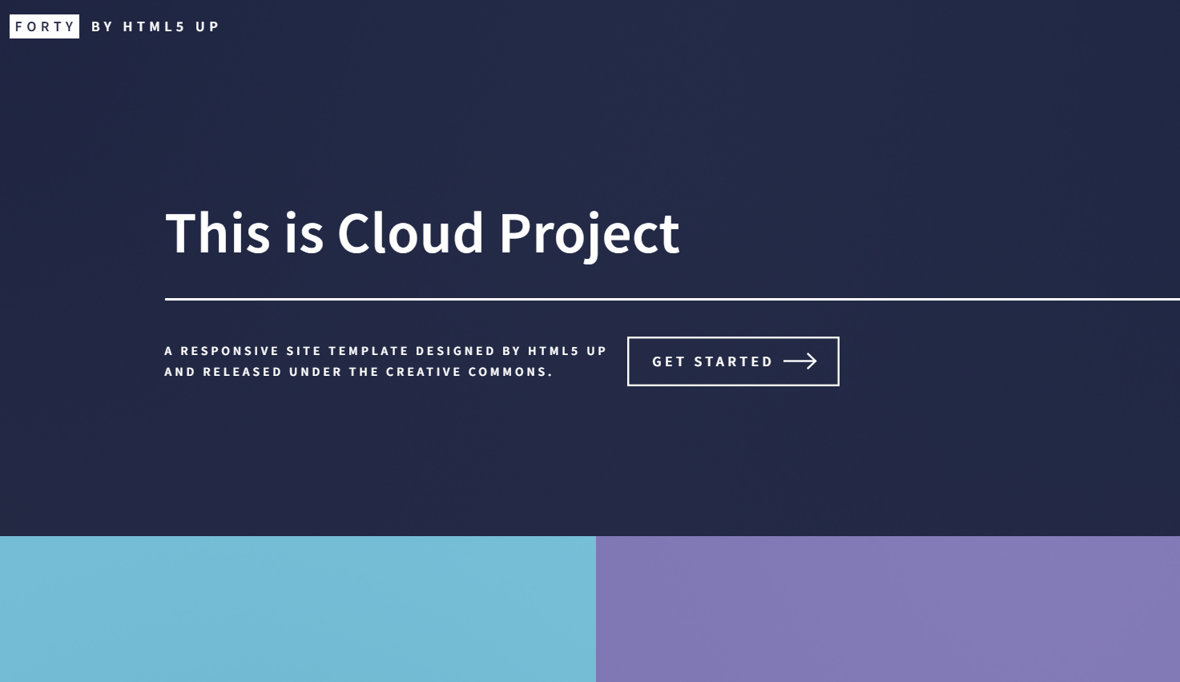

Summary of What We Did:
- Created a private Amazon S3 bucket to store static website files.
- Configured Amazon CloudFront distribution with the S3 bucket as origin.
- Enabled Origin Access Control (OAC) to keep the S3 bucket private.
- Routed user requests through CloudFront edge locations.
- Cached content at edge locations to reduce latency.
- Prevented direct public access to the S3 bucket.
- Achieved secure and faster global content delivery.

